1.Write a hive query to find the top 20 destination people travel the most: Based on the given data

To get the to 20 destinations we have selected the location and summed the adults, child, infants, senior citizens, etc . and used alias as total and ordered desc by total to get the top destinations travelled and we have limited it to 20 as per our requirement we can limit to any number

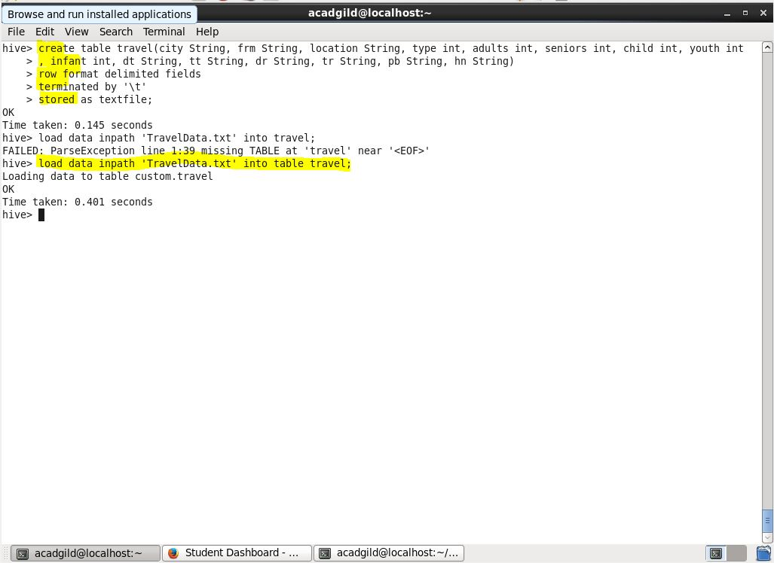

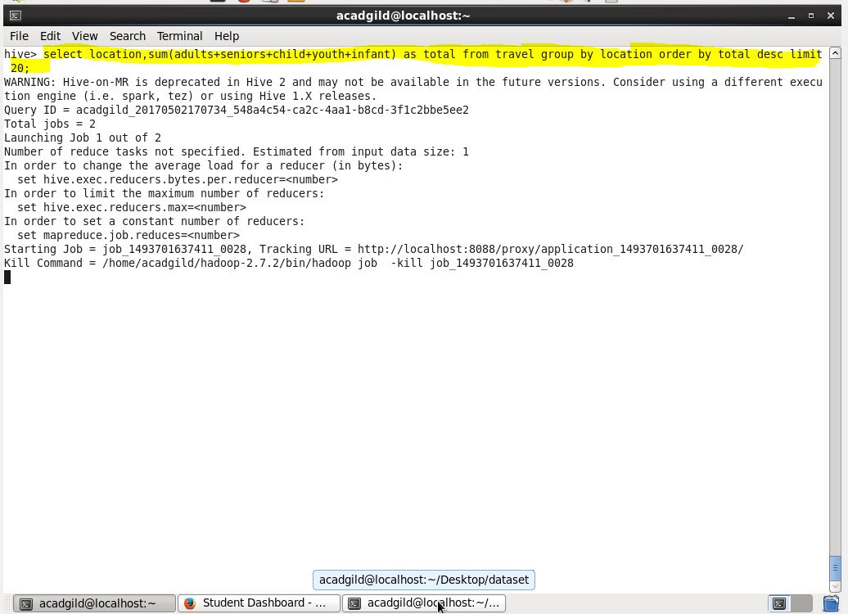

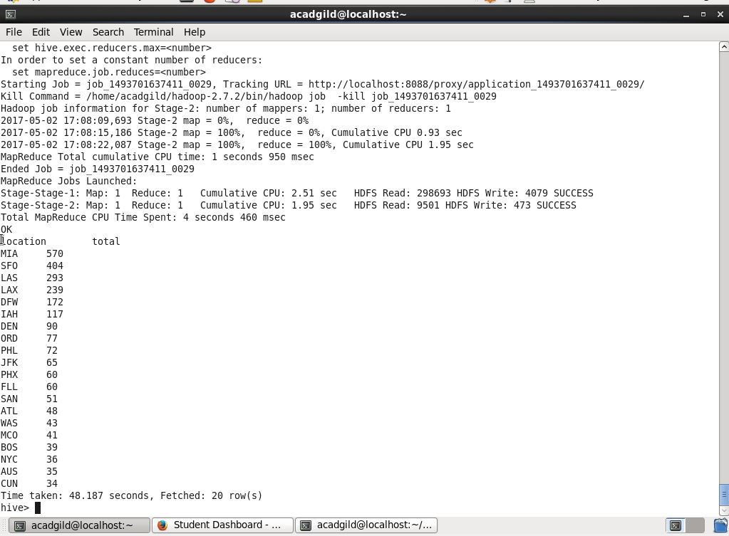

2. Write a hive query to find the top 20 locations from where people travel the most

To get the to 20 locations we have selected the frm and summed the adults, child, infants, senior citizens, etc . and used alias as total and ordered desc by total to get the top location from where people travelled and we have limited it to 20 as per our requirement we can limit to any number



